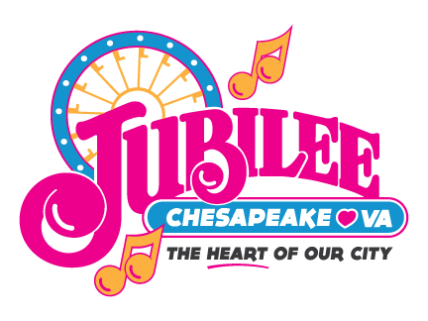
2017 CHESAPEAKE JUBILEE
TRAFFIC CONTROL RULES AND REGULATIONS
ACKNOWLEDGEMENT
In an effort to facilitate the movement of emergency vehicles, reduce the risk of injury to pedestrians due to vehicles moving on the site, and to protect features of the new Park, the Jubilee Logistics Committee will restrict traffic movement before, during, and after festival hours.
NO VEHICLES WILL BE ALLOWED OFF OF PAVED SURFACES, EXCEPT IN DESIGNATED PARKING AREAS. NO VEHICLE WILL BE ALLOWED TO TRAVEL ON, OR TO CROSS SIDEWALKS OR AREAS WITH SOD. THOSE WHO FAIL TO ABIDE BY THESE RESTRICTIONS WILL BE SUBJECT TO REMOVAL FROM THE PARK. THEY MAY ALSO BE HELD FINANCIALLY RESPONSIBLE FOR ANY DAMAGE CAUSED.
Site Access:
The Jubilee Site will be closed to all vehicles without passes during the following hours:
FRIDAY 10 A.M. TO SUNDAY 6 P.M.
There will be no movement of vehicles on site, unless the vehicle displays a valid Jubilee pass. Passes must be clearly visible on the front dashboard.
** No vehicular traffic will be allowed on the center road**
Any other traffic will be subject to approval of the Jubilee staff. Access to the site without a proper pass must be approved by a Jubilee representative and coordinated with the Police Department.
Vehicles on site without approved passes will be subject to towing.
*** NO PARKING WILL BE ALLOWED ON, OR ALONG ANY ROADWAY ***
TYPES OF PASSES
VENDOR
ALL VENDORS MUST REPORT TO VENDOR REGISTRATION BEFORE BEING ALLOWED FURTHER ACCESS THE SITE. A JUBILEE REPRESENTATIVE MUST ACCOMPANY THE VENDOR TO THEIR SITE BEFORE SETUP WILL BE ALLOWED.
Vendors will be limited to 2 vendor passes which will allow access to the Jubilee Site and 2 participant passes which will allow access to the participant parking area at the Greenbrier Sports Complex, which is beside the YMCA. Do not park at the YMCA ... you will be towed. Additional participant passes may be requested if needed.
Each "Vendor" pass must be assigned to a specific vehicle, and displayed on the front dashboard at all times while on the Jubilee Site.
VEHICLE PARKING AT VENDOR SITES WILL NO LONGER BE ALLOWED.
All vendor sites must be re-stocked before and after Midway hours. Exceptions to this will be limited and must be approved by Jubilee Staff. Escort service must be provided for any Vendor vehicle moving on site during normal hours.

PARTICIPANT
Participant passes will be issued to Jubilee Volunteers and staff persons for the various booth operations.
A shuttle service will be available for participants to and from the designated parking area at the Greenbrier Sports Complex.
*** Admission gates close at 9 p.m. on Friday and Saturday night, and 6 p.m. on Sunday. Have your passes, if you are leaving the site and need to get back in before 10 p.m. closing.

FREE PARKING LOT A
Invited dignitaries and guests will be provided a “FREE PARKING LOT A" pass. This will allow free parking at the lot located on Greenbrier Parkway.
ENTERTAINMENT
Entertainers will be given passes to allow access on site. Passes are color coded for access to either the Main Stage, Jubilee Stage, or Chesapeake Stage. You will be directed to the stage where you will be performing.
SERVICE VEHICLE
Vehicles needed to provide various services to the Jubilee Site will be given Service Vehicle passes. Service Vehicle passes will allow access to the site at any time. Service trucks should be parked in the Service Vehicle parking area. Personal vehicles with service passes should park in a designated parking area. Service vehicles must enter the site from the Kempsville Road entrance, located between the Kempsville Shoppes and the Railroad tracks.
OFFICIAL
Members of the Jubilee Executive Committee and their designated representatives will be given Official passes. This will be an unrestricted pass, and will allow access onto the Jubilee Site at any time. Vehicles with Official passes must park in designated parking areas.

.

