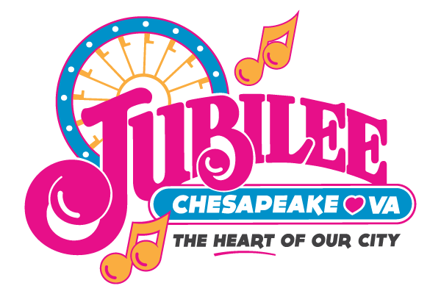
2017 KCBS BBQ Winners
Grand Champion: 3N1Q
Reserve Grand Champion Wolf’s Revenge BBQ

Chicken:
1st Place: Colonial Embers
2nd Place: Smoke-Aholics
3rd Place: 3N1Q

Pork Ribs:
1st Place: Wolf’s Revenge BBQ
2nd Place: Pigs on the Run
3rd Place: Buttman and Rubbin

Pork:
1st Place: Buttman and Rubbin
2nd Place: Aporkalypse Now
3rd Place: Wolf’s Revenge BBQ

Brisket:
1st Place: 3N1Q
2nd Place: Slick’s Bar-B-Que
3rd Place: Grate Smoke BBQ

